Instacart Recommendation Systems
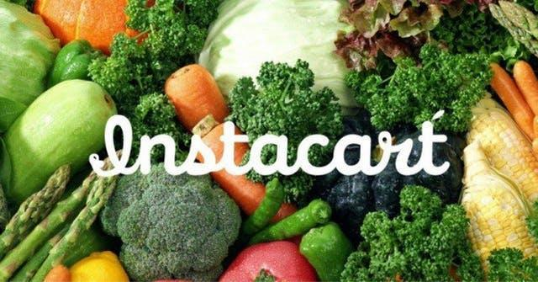

Final Project

Instacart Recommendation Systems

Jigyasa Kohli

Tushar Goel

12/12/2017

1 | P a g e
Instacart Recommendation Systems

Contents

Business Case 4

Recommendation Systems 4

Instacart Recommendation Systems 4

Our Goal 4

Our Approach 4

Stakeholders Benefited 5

Instacart Dataset 5

As our initial step we tried to understand the data and the nature of the dataset. Exploratory Data

Analysis would help understand trends and patterns 5

Project Work Flow 6

Data Ingestion 7

Exploratory Data Analysis 10

Instacart Inventory Details 10

Total Instacart Users 11

Total Count of Instacart Customers 12

Sales Distribution by Department 13

Sales by Day of the Week 14

Orders placed by Department 15

Analysis : We can clearly see that some departments have really infrequent sales. This helps us to
decide the clustering as well as eliminate some of the departments from recommending 15

Top 10 Popular Departments 16

Next, we observed the most popular departments 16

Most visited aisles among the popular departments 17

Top 10 famous Aisles among Customers 18

10 Popular Products among Users 19

Users with the most Orders 20

We observed the users with the most orders 20

Top 20 users with most Orders 21

Trend of Top Products Bought by Day of the Week 22

Count of Products Ordered on Day Of Week 23

2 | P a g e
Instacart Recommendation Systems

Trend of Orders by the Hour 24

Purchases with maximum Products by Users and by Day of Week 25

Frequency of orders by Day of week and Hour of day 26

Number of Reorders 27

Reorder ratio by Order of Day and Order Of Week 28

Products with the most Reorders 29

Count of Days since Prior Order 30

EDA Summarization 30

Recommendation Systems Implementation for Instacart 31

Recommendation Systems 31

Business Logic for recommendations 31

Rating was calculated on the basis of the following: 31

Rating= count(Products Bought by a user))/(Count of product bought by the user most number

times)*100 31

Scope 32

Results of the recommendation model showing the best precision and recall 32

Importance of heuristics 36

Model Deployment 36

Apriori Algorithm 39

Significance in Instacart Recommendation Systems 39

Apriori Algorithm Implementation Details 39

Manual Clustering by Departments 40

Use Apriori and deriving rules using Association Rule Mining 40

Implementation on the Web Application 51

Conclusion 51

3 | P a g e
Instacart Recommendation Systems

Business Case

Recommendation Systems

Recommendation systems have impacted and redefined our lives in many ways. The internet has opened us to wide a range of possibilities making it important to provide relevant information in order to alleviate the problem of information overload. Hence, a recommender system solves this problem by searching through a large volume of dynamically generated content to provide personalized content and services.

This approach has percolated to various industries and markets. Instacart is one such company that is leading the way for online grocery shopping. Instacart allows users to purchase products online from a variety of departments and deliver these at a user’s door step. Following this business model requires the need of recommender systems to make a user’s experience better and in turn encourage them to return buying with Instacart. This also has an additional advantage as it also lures new customers to return due to the fruitful user experience.

Instacart Recommendation Systems

Our Goal

Our aim was to create a recommendation system for Instacart. The recommendation system would help

Instacart as follows:

- Instacart has a faithful following of users. Hence, Recommender system has the ability to predict whether a particular user would prefer an item or not, based on the user’s profile. This helps the seller and the consumer.

- Instacart benefits as recommender systems reduce the transaction cost of finding and selecting items in an online shopping environment

- Instacart Users benefit as this will improve the decision making process and quality

- Recommender systems enhance revenue as it effectively enables selling products and hence, benefits by increasing revenues.

- This also allows users to beyond catalog searches.

Our Approach

We have primarily used the following recommendation Systems:

- Collaborative Filtering Technique – Model Based Filtration technique

- Association Rule Mining – Apriori Algorithm

4 | P a g e
Instacart Recommendation Systems

Stakeholders Benefited

- Instacart will benefit by enhanced revenues and retain its faithful customers luring them to come back each time

- Instacart Customers will be the beneficiaries of this system as they will experience a better user experience, and also allow them to narrow their search based on the wide variety of products that Instacart provides. Thus, improving the decision making experience as well.

In order to achieve our goal we used the Instacart Dataset that has been made public. The details of the dataset are present below.

Instacart Dataset

The Instacart Dataset provided us with 3 million orders. The dataset provided information on the product, the department it belonged to and the aisle it belonged with. Additional characteristics also included the time of day of purchase, the day of the week of the purchase and if the product had been reordered by the customer before.
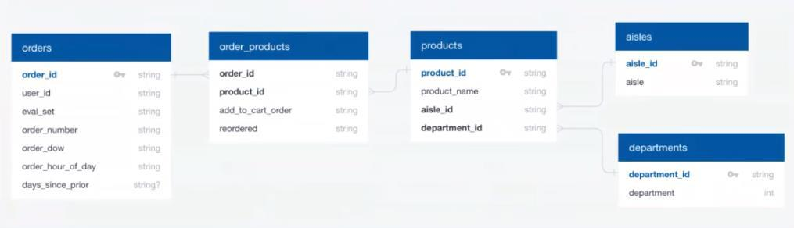

As our initial step we tried to understand the data and the nature of the dataset. Exploratory Data Analysis would help understand trends and patterns

5 | P a g e
Instacart Recommendation Systems

Project Work Flow

Data Ingestion was done followed by dockerizing and creating the Luigi Data Pipeline. The data is used for Exploratory Data Analysis, Heuristics Calculation, Feature Engineering and Creation of Recommendation Systems . The result set of the models is placed in the CSV’s as due to volume of data and then used on the WebApp hosted on the Google Cloud Platform


Data Ingestion
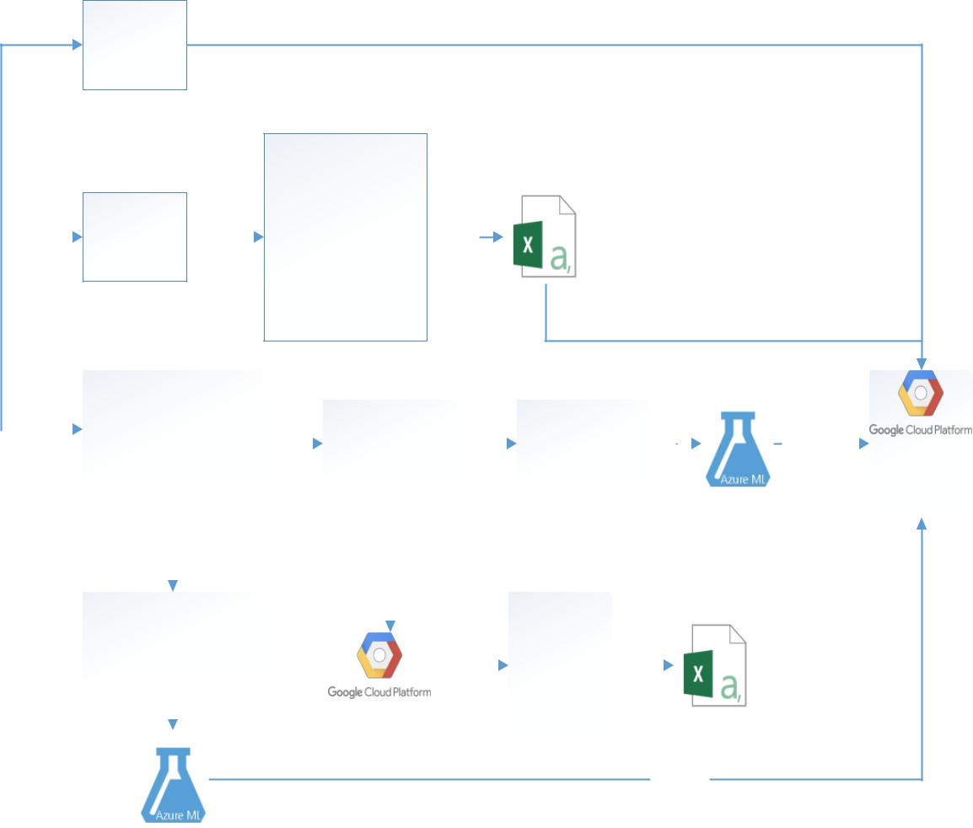

EDA

- Top Selling Products of all time
- Top selling Product per
 |  |  |  |  | Calculate |  | department
Has Luigi Pipeline |  |  |  |  | Calculate |  | 3. Top Selling Product for
 |  |  |  |  | Calculate |  | 3. Top Selling Product for |  | To csv
 |  |  |  |  | Heuristics |  | that Day of week
- Top Selling Product for the hour of day

- Top Selling product for the time of that day

Downloads
 |  |  |  |  |  |  |  | Feature Engineering
Data from
 |  |  |  |  |  |  |  |  |  |  |  |  |  |  |  |  |  |  | Model Based
 |  |  |  |  |  |  |  | (Manipulations & |  |  |  |  | Cluster on
internet |  |  |  |  |  |  |  |  |  |  |  |  |  |  |  |  |  |  | Recommendation |  |  |  |  |  |  |  |  |  | REST API
 |  |  |  |  |  |  |  | Calculating Ratings) |  |  |  |  | Department |  |  |  |  |  |  |  |  |  |  |  |  |  |  |  | REST API
 |  |  |  |  |  |  |  |  |  |  |  |  |  |  |  |  |  |  | on All Data |  |  |  |  |  |  |  |  |  |  |  |  | WEB APPLICATION
Handles Missing Values
And Merged Data
Merged
 |  |  |  |  |  |  |  | Model Based |  |  |  |  |  |  |  |  |  |  | Apriori
Dataset |  |  |  |  |  |  |  |  |  |  |  |  |  |  |  |  |  |  | Apriori
 |  |  |  |  |  |  |  | Recommendation on All |  |  |  |  |  |  |  |  |  |  | Apriori
 |  |  |  |  |  |  |  |  |  |  |  |  |  |  |  |  |  |  | Algorithm
 |  |  |  |  |  |  |  | Data |  |  |  |  |  |  |  |  |  |  | Algorithm
 |  |  |  |  |  |  |  |  |  |  |  |  |  |  |  |  |  |  | For
 |  |  |  |  |  |  |  |  |  |  |  |  |  |  |  |  |  |  | For |  | To csv
 |  |  |  |  |  |  |  |  |  |  |  |  |  |  |  |  |  |  | Association
 |  |  |  |  |  |  |  |  |  |  |  |  |  |  |  |  |  |  | Rule Mining

REST API

6 | P a g e
Instacart Recommendation Systems

Data Ingestion

We merged the Instacart dataset and handled missing values in the Prior Orders csv’s. Next, we dockerized the image and created a Luigi Pipiline for the same.
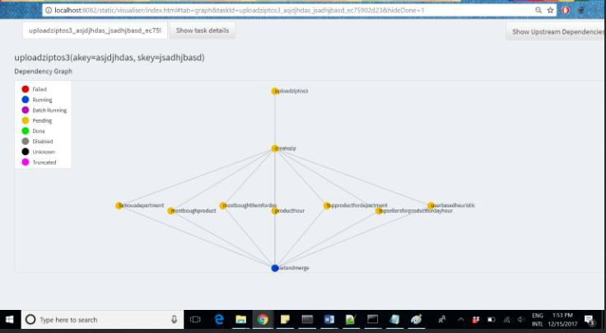

7 | P a g e
Instacart Recommendation Systems
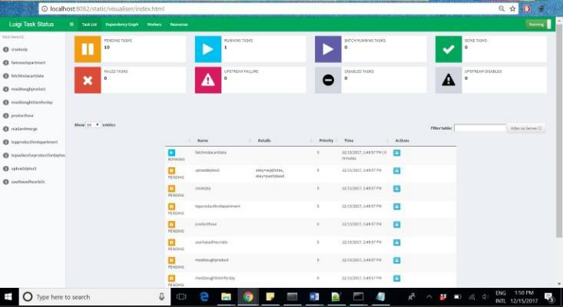

8 | P a g e
Instacart Recommendation Systems

9 | P a g e
Instacart Recommendation Systems

Exploratory Data Analysis

In order to understand the data we first tried to understand the inventory, the users and the patterns, if any.

Instacart Inventory Details

Instacart has a total of 49689 products, 21 Departments and 134 Aisles.
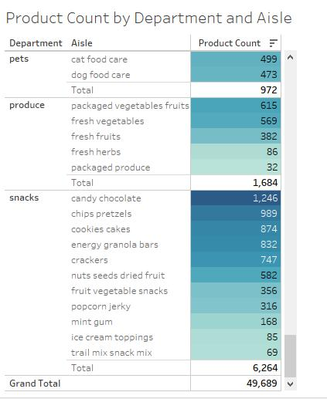

10 | P a g e
Instacart Recommendation Systems

Total Instacart Users
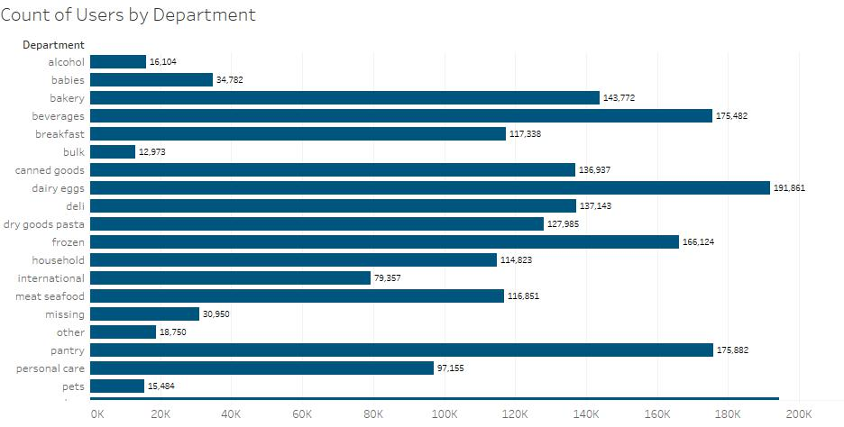

11 | P a g e
Instacart Recommendation Systems

Total Count of Instacart Customers
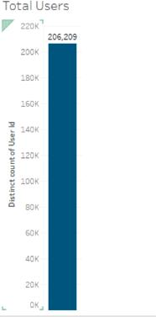

12 | P a g e
Instacart Recommendation Systems

Sales Distribution by Department

Next, observe the sales distribution by Department
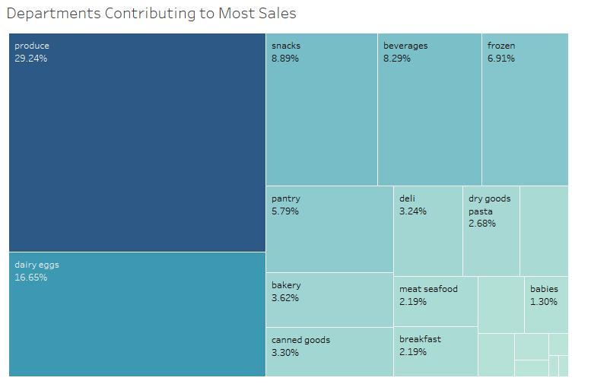

Analysis: We observe that Produce, Dairy Eggs and Snacks are the maximum Departments that contribute to sales

13 | P a g e
Instacart Recommendation Systems

Sales by Day of the Week

Next, we observed a pattern in the sales by Day of the Week.
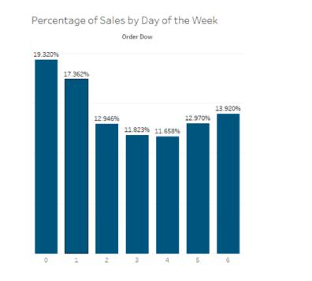

Analysis : More than 35% of orders are placed in just two days. This summary metric can help Instacart on their restocking capability. This also helps us study a buying patter, by day.

14 | P a g e
Instacart Recommendation Systems

Orders placed by Department

Next, we observed if there was a pattern of orders dedicated to a particular department.
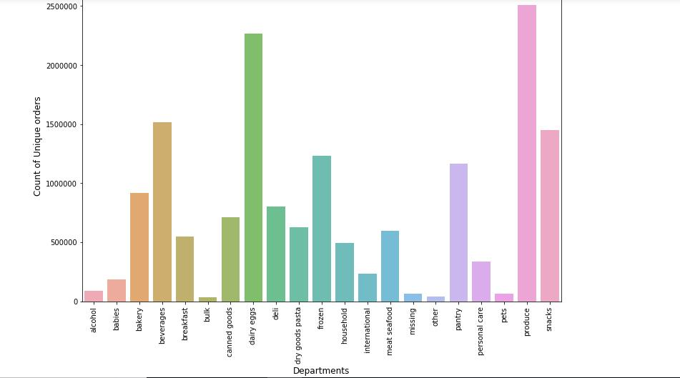

Analysis : We can clearly see that some departments have really infrequent sales. This helps us to decide the clustering as well as eliminate some of the departments from recommending

15 | P a g e
Instacart Recommendation Systems

Top 10 Popular Departments

Next, we observed the most popular departments
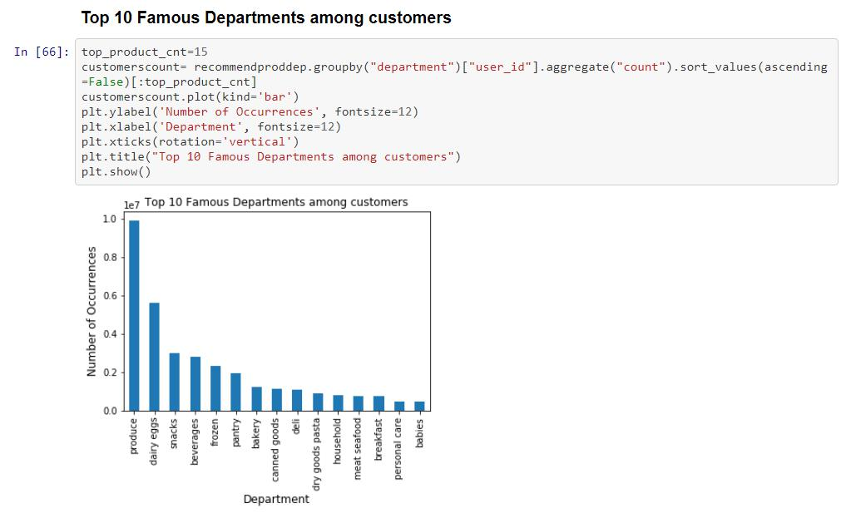

Top 3 Famous Departments among customers are:

Produce dairy eggs snacks

This indicates that Instacart is most popular for its Produce Department which deals in fresh vegetables and fruits

16 | P a g e
Instacart Recommendation Systems

Most visited aisles among the popular departments
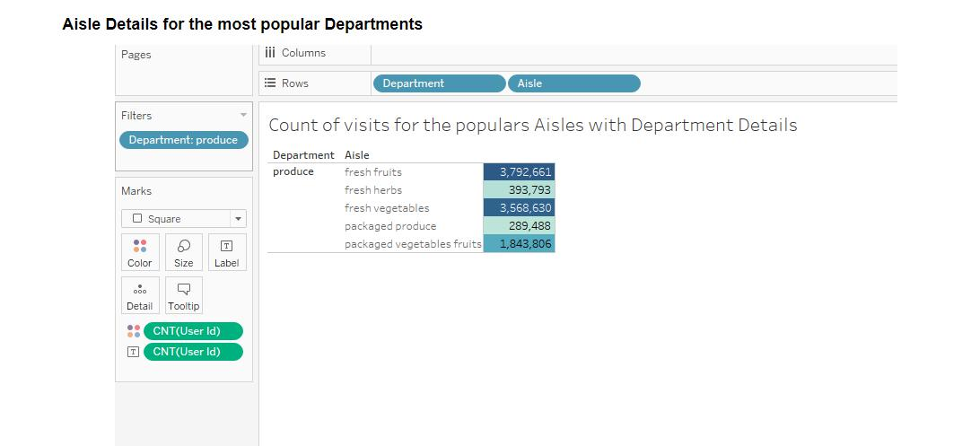

From this visualization it can be analyzed that the most popular Aisles are Fresh Fruits and Fresh Herbs in the Produce Department

17 | P a g e
Instacart Recommendation Systems

Top 10 famous Aisles among Customers
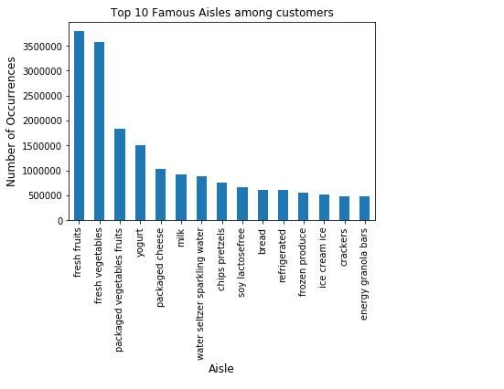

18 | P a g e
Instacart Recommendation Systems

10 Popular Products among Users

From the above visualization we observe that most popular aisle also belongs to the most popular Department – Produce
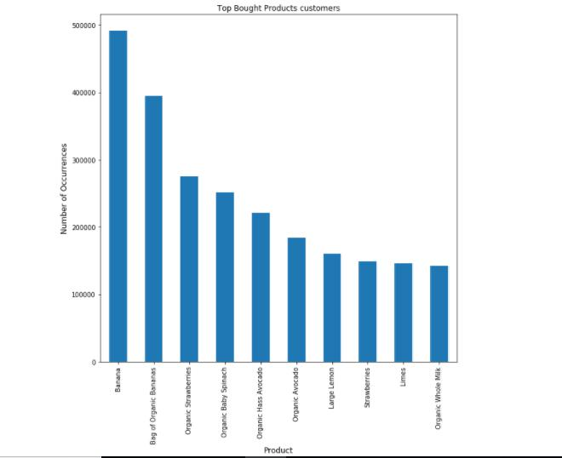

Among the top 10 products most popular products Banana, Bag of Organic Bananas Organic Strawberries. Additionally, they also belong to the most popular department and most popular aisle

19 | P a g e
Instacart Recommendation Systems

Users with the most Orders

We observed the users with the most orders
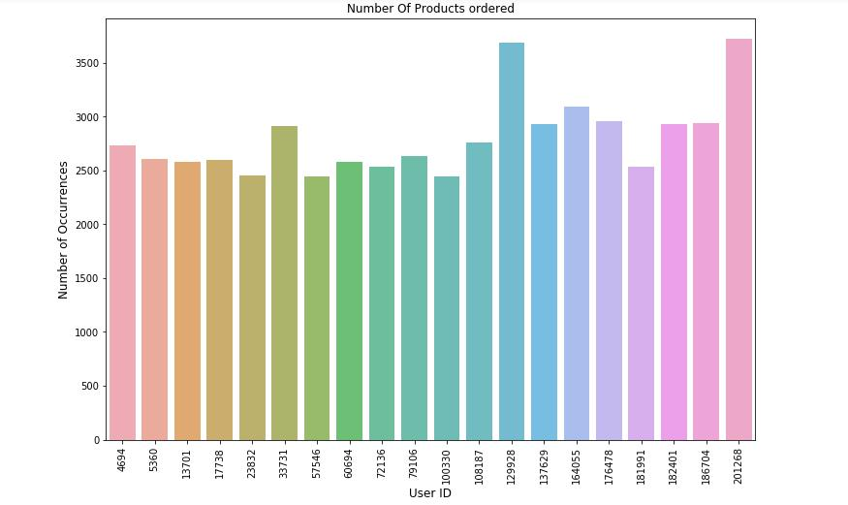

Result: We observe that userid 201268 has purchased the most number products, followed by userid 12998

20 | P a g e
Instacart Recommendation Systems

Top 20 users with most Orders
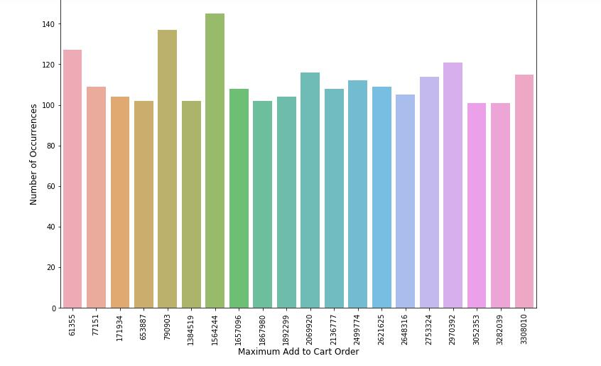

Maximum products added to cart orders are:

Order Number 1564244 Order Number 790903

This also indicates the maximum products were bought in the above order id’s specified

21 | P a g e
Instacart Recommendation Systems

Trend of Top Products Bought by Day of the Week
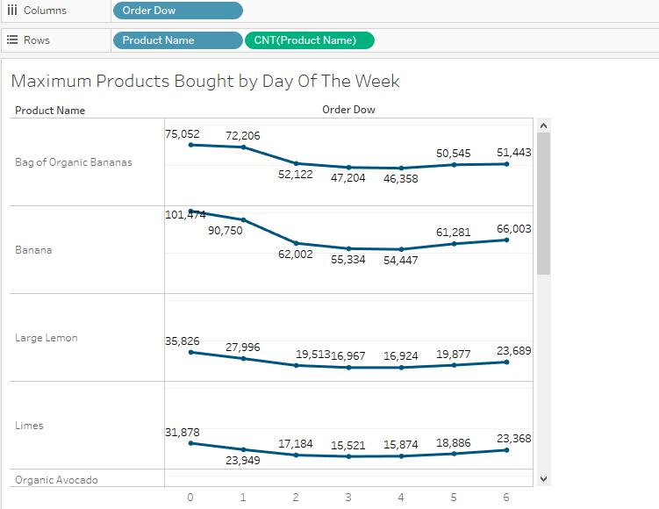

Most of the popular products are bought on Sunday. The Trend depicts they are bought the most from Sunday to Wednesday with a slight dip in purchase for the rest of the week

22 | P a g e
Instacart Recommendation Systems

Count of Products Ordered on Day Of Week
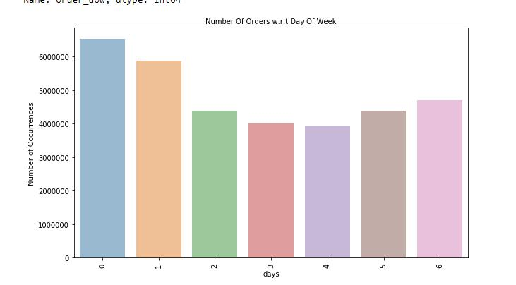

Majority of the orders are placed on Day 0 and Day 1 , that is Saturday and Sunday and the least number of orders were placed on Wednesdays.

23 | P a g e
Instacart Recommendation Systems

Trend of Orders by the Hour
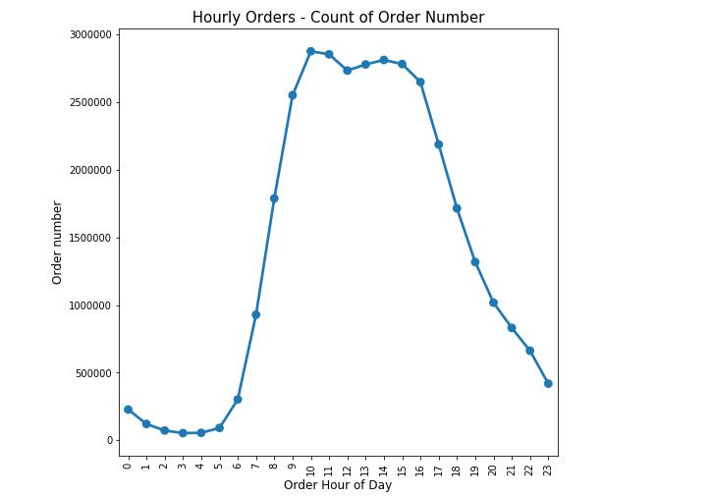

Maximum Ratio of Weekly Orders - Count of Order Number is between :

- 11:00 am and 17:00 pm hours of the day

Most products bought in an order by day of the week by a particular user

24 | P a g e
Instacart Recommendation Systems

Purchases with maximum Products by Users and by Day of Week
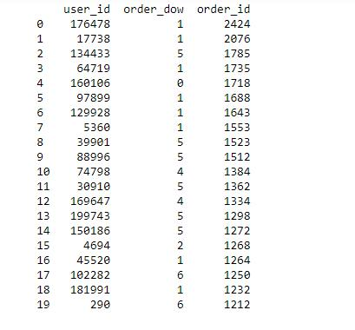

Most products were bought in orders purchased on Sunday. This table might also suggest that users purchase more on a particular day of the week

25 | P a g e
Instacart Recommendation Systems

Frequency of orders by Day of week and Hour of day
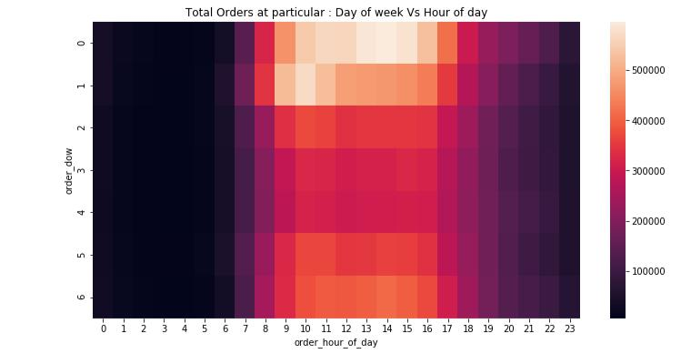

We can see very few orders are place before 8 am and most of the orders are done on Saturday and Sunday from 9 am to 5 pm

- Saturday Evenings

- Sunday Mornings are the prime time for the customer orders

This helps us understand that customers predominantly purchase on the weekends

26 | P a g e
Instacart Recommendation Systems

Number of Reorders

Next, we observed Number of Times any Product is Re-ordered
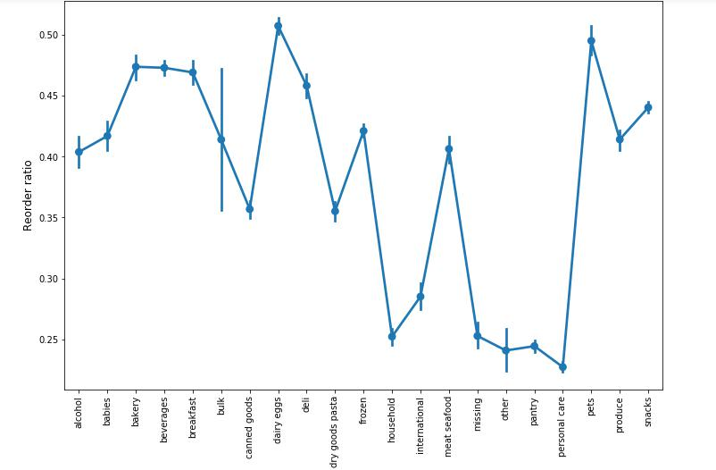

Using this we can use this data on department clustered recommendation algorithm and make amount of predictions accordingly. As per the above result the probability of Reorders is the highest for the Department Produce

27 | P a g e
Instacart Recommendation Systems

Reorder ratio by Order of Day and Order Of Week

We, studied the reorder ratio of order of the day vs Order of the week
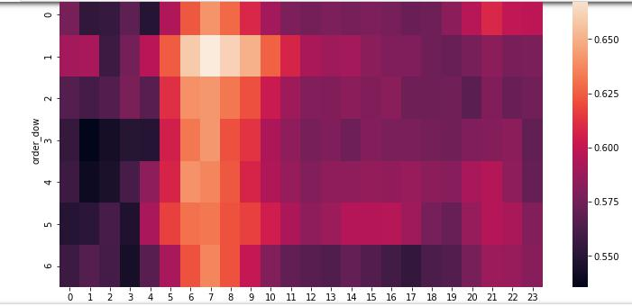

This indicates that maximum reorders have occured 6 am to 8 am on all days with the maximum being on Sunday

Orders_product_prior with reordered items
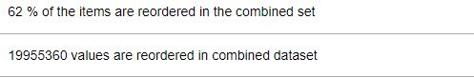

28 | P a g e
Instacart Recommendation Systems

Products with the most Reorders
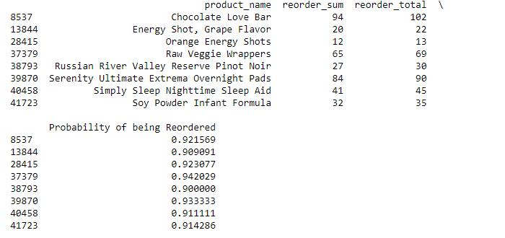

The Chocolate Love Bar ,Energy Shot , Grape flavor are the items with the most reorder

29 | P a g e
Instacart Recommendation Systems

Count of Days since Prior Order
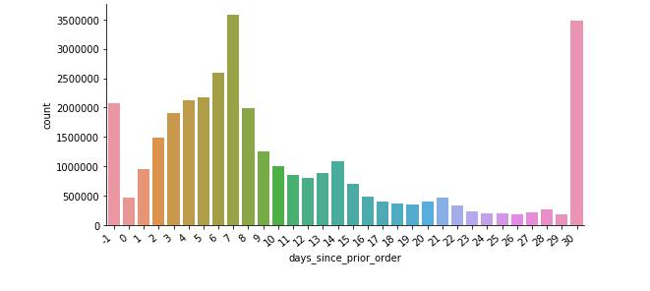

We can see that customers order maximum once in every week or every month, after a sudden fall in customers order after 7 days, at 14 and 21 days gain there is a little small peak in comparison to rest of the other days.

EDA Summarization

Analysis of EDA provided us insightful evidence on the users buying pattern. It explicitly outlines that the majority of the users prefer buying on weekends. Moreover, it is observed that most orders are dedicated to a particular department. This implies that a user always returns to the department that he purchases from the department type. Additionally a user purchases almost 20% of the products from one department in a given order.

As a result, this enables us to cluster our data for recommendations and associations based on a department as well

30 | P a g e
Instacart Recommendation Systems
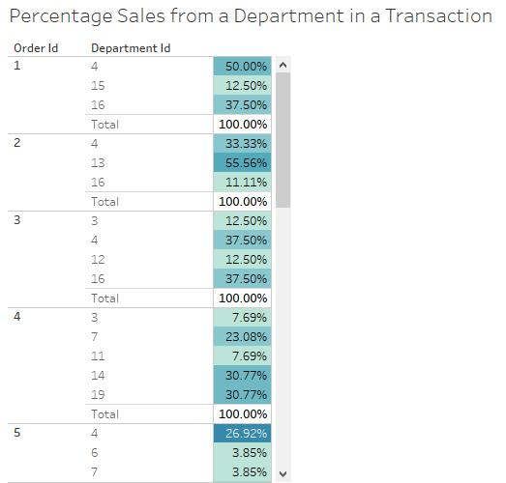

Recommendation Systems Implementation for Instacart

Recommendation Systems

Business Logic for recommendations

Rating was calculated on the basis of the following:

Rating= count(Products Bought by a user))/(Count of product bought by the user most number times)*100
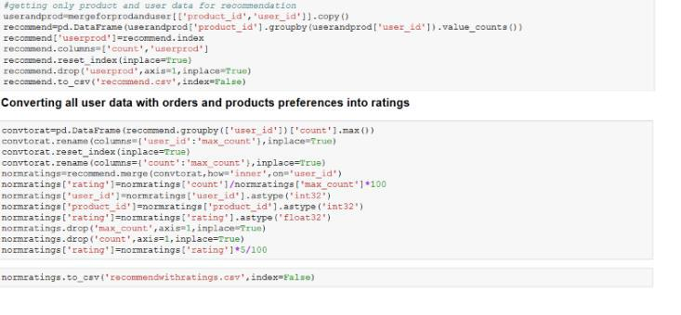

31 | P a g e
Instacart Recommendation Systems

Scope

The scope of project includes Model Based Collaborative Filtering which fetched the best results. Instacart has provided a rich dataset that allows us to study past behaviors to provide recommendations to users. We have implemented model based collaborative filtering using the Graphlab Library Framework because it utilizes Spark Clusters on IBM-DSX providing high computation power. We tested our dataset on 3 models:

- Item Based Recommendation Models

- Popularity Based Recommendation Model

- Model Based Recommendation Models (Latent Models): Latent models are used to shrink user traits into latent features. This is based on the matrix factorization model and is widely used for recommendation systems where it can better deal with scalability and sparsity. The goal of model based collaborative filtering is learn the latent preference of users and the latent attributes of items from known ratings.

Results of the recommendation model showing the best precision and recall

Model Based Recommendation provided the best results after trying all the other models. The Dataset was used without any clustering to run Item Based, Popularity Based and Model Based recommendations to compare and select the best results.

1. All Data
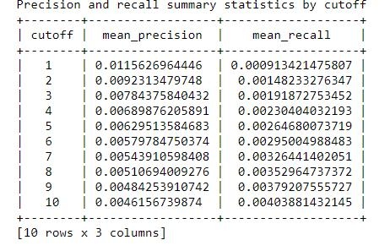

- Clustering on the basis of aisle : Precision and Recall

32 | P a g e
Instacart Recommendation Systems
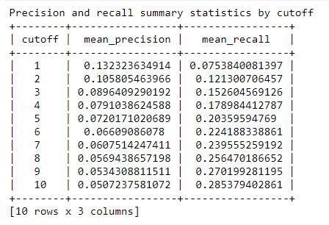

- Clustering on basis of particular Hour of the Day :
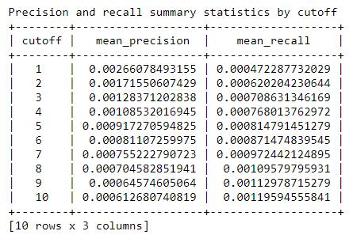

33 | P a g e
Instacart Recommendation Systems

4. Clustering on the basis of Department
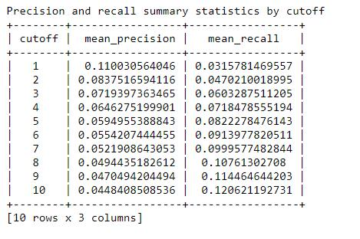

5. Clustering on the basis DOW Recommendation

34 | P a g e
Instacart Recommendation Systems
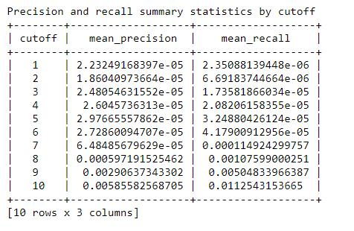

6. Clustering on the basis of hour of the product was bought :
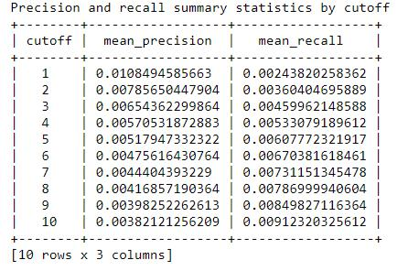

35 | P a g e
Instacart Recommendation Systems

Importance of heuristics

Heuristics have been used to provide basic recommendation when a new user visits in Instacart.

List of Heuristics Used:

- Most Bought Product of all time

- Most visited department

- Most frequently bought products by the specific user

- Most frequently bought products on that hour

- Most frequently bought product on that day

- Most frequently bought product on that hour of that day

- Most Reordered product by that user

Model Deployment

The recommendation models are deployed in Azure using Train Matchbox Recommender Train Matchbox Recommender

The Train Matchbox recommend uses a popular ranking matrix called NDGC (Normalized Discounted Cumulative Gain). It allows a relevant score in the form of real numbers. If there is no feedback for an item then the gain is set to 0. If not then the recommender returns some items which has a relevance score usually a non-negative number which is being added up known as Cumulative Gain. The matchbox recommender combines collaborative filtering with a content based approach. When a user is relatively new to the system, predictions are improved by making use of the future information of the user. Even, if the user item features are not available matchbox will still work in its collaborative filtering mode.

36 | P a g e
Instacart Recommendation Systems

Azure Deployment Screen Shots

Model Deployment on Full Data
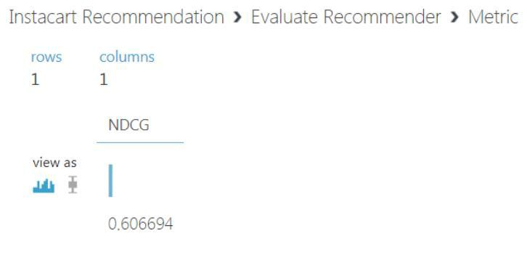

Model Deployment on Department Cluster
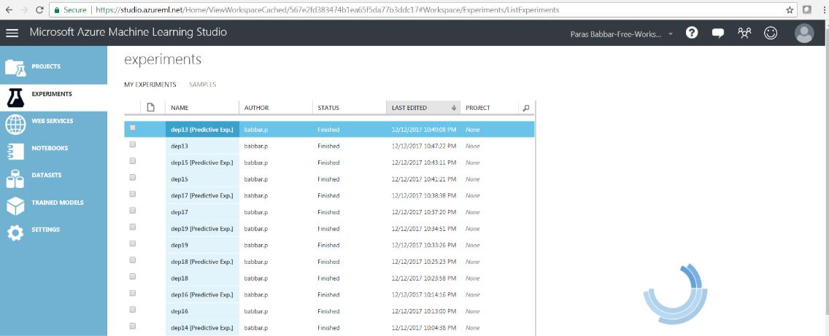

37 | P a g e
Instacart Recommendation Systems
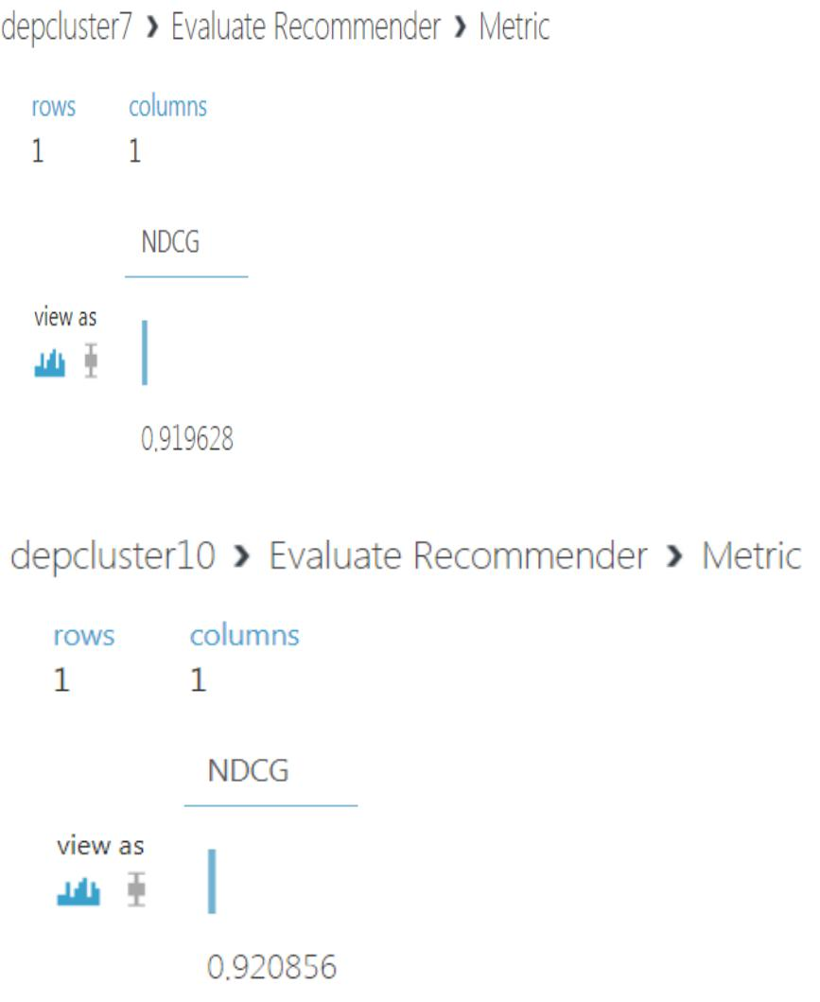

38 | P a g e
Instacart Recommendation Systems

Apriori Algorithm

Significance in Instacart Recommendation Systems

Apriori Algorithm is influential algorithm for mining frequent item sets. It uses a bottom up approach where frequent subsets are extended one item at a time. The diagrammatic representation indicates the working of Apriori Algorithm
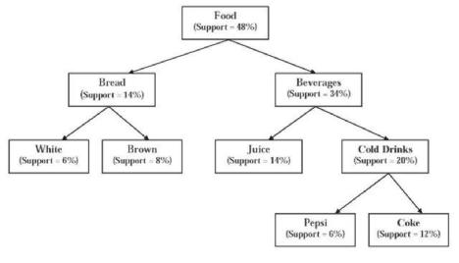

It then makes use of Association Rule Mining to get the association rules in the data.

Instacart Recommendations benefit from these models as it provides the user options on various items based on the associated items selected for purchase. This improves the user experience of a customer visiting the Instacart webpage.

Apriori Algorithm Implementation Details

In order to find associations among the various products in the dataset, we clustered the data by departments. We manually clustered by departments due to the following reasons:

- A Transaction made by a user consists of products majorly associated with one department

- A returning user generally visits the department that he visited in the previous orders

39 | P a g e
Instacart Recommendation Systems

Manual Clustering by Departments

Manual Clustering is done by Departments
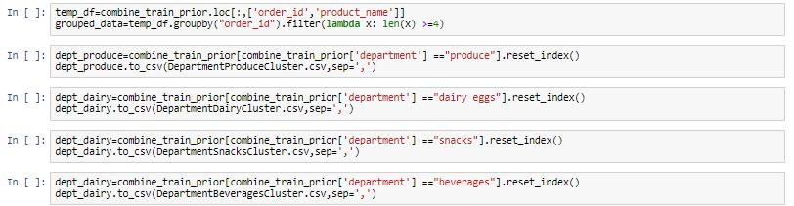

Use Apriori and deriving rules using Association Rule Mining

All association rules have been derived with metrics as follows:

Minimum Support – 0.01

Lift (minimum threshold)-1

Confidence – 30%

Conviction – 40%

40 | P a g e
Instacart Recommendation Systems

Department Produce
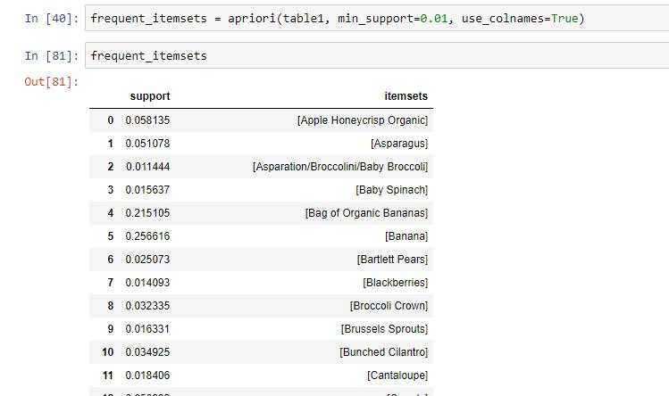

Association Rules
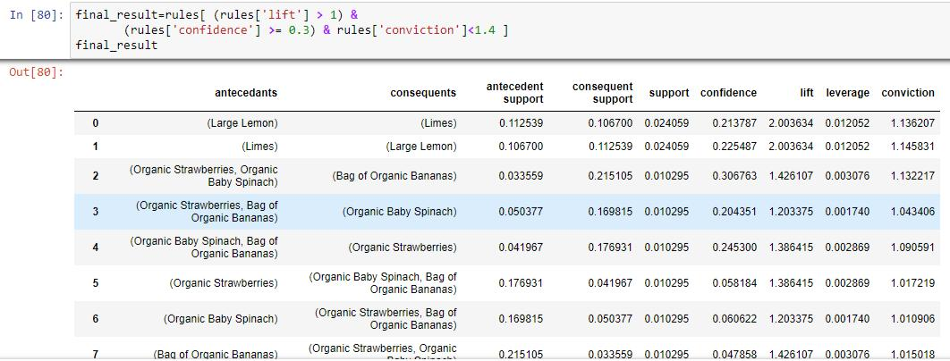

Result Analysis: Large Lemon and Limes and Limes and Lemon are most frequently associate with high Lift value of 2 and small conviction and confidence of 13 % and 20 % respectively

41 | P a g e
Instacart Recommendation Systems

Department – Dairy Eggs
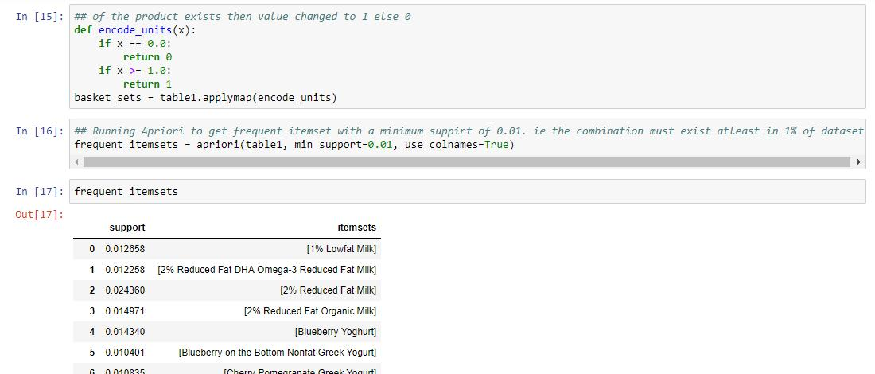
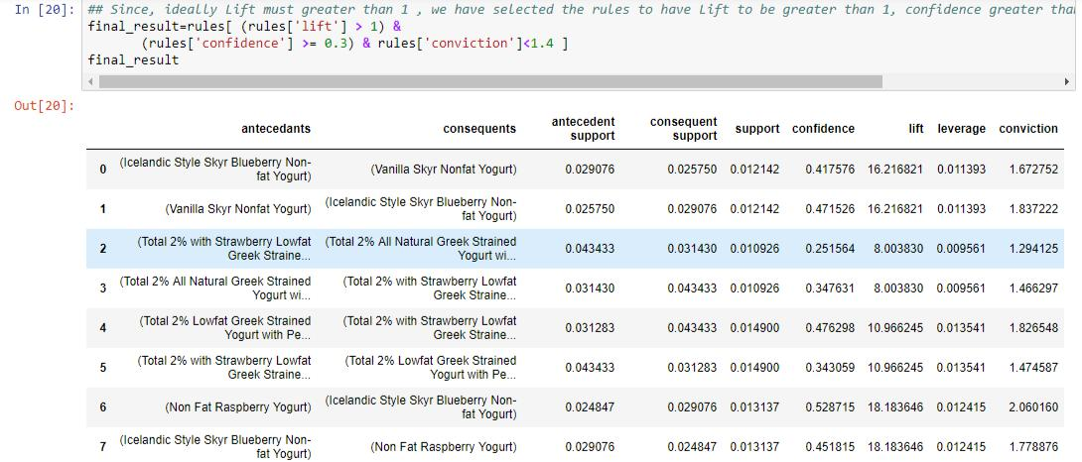

Result Analysis: Non fat raspberry and Blueberry Non fat Yogurt are most frequently associate with high Lift value of 18.

42 | P a g e
Instacart Recommendation Systems

Snacks
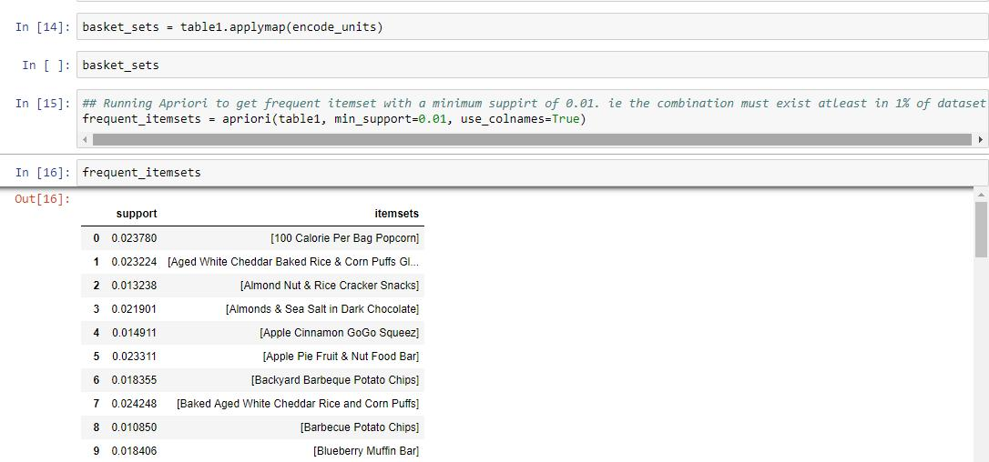

There were no associations found for this department

Department Frozen
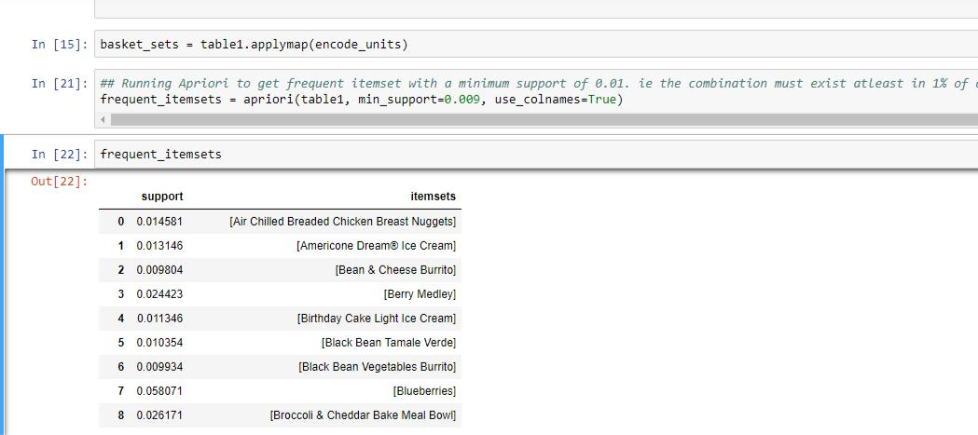

43 | P a g e
Instacart Recommendation Systems
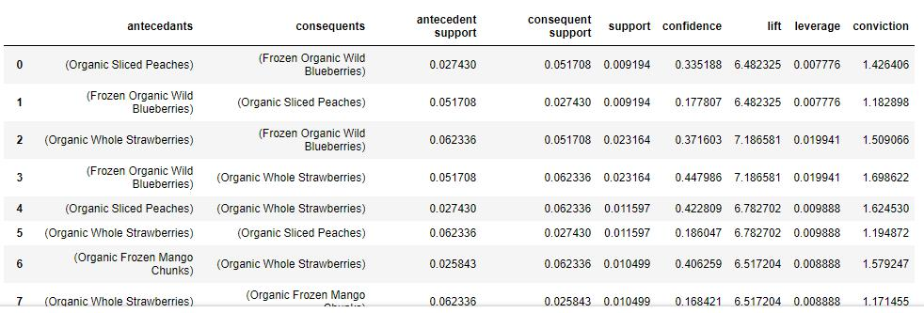

Result Analysis: Organic Whole Strawberries and Organic Blueberries are most frequently associate with high Lift.

Pantry
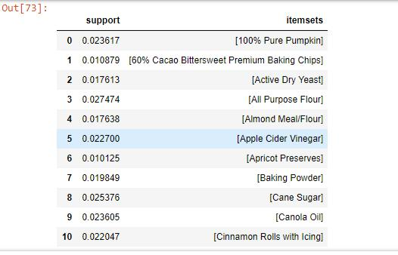

Result Analysis: No Asscoiation Rules were found

44 | P a g e
Instacart Recommendation Systems

Department Canned Goods
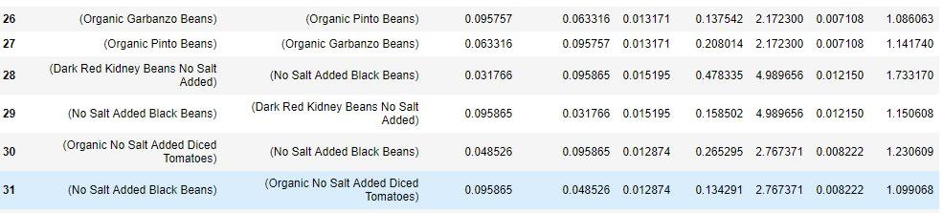

Result Analysis: RedKidneyBeans and Black Beans are always bought together as they seem to have a large Lift value

Deli
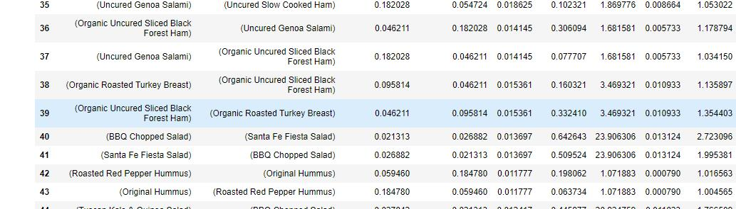

Result Analysis : BBQ Chopped Salad and Santa Fe Fiesta Salad have high associations with high lift values of 23

45 | P a g e
Instacart Recommendation Systems

Department GoodsPasta
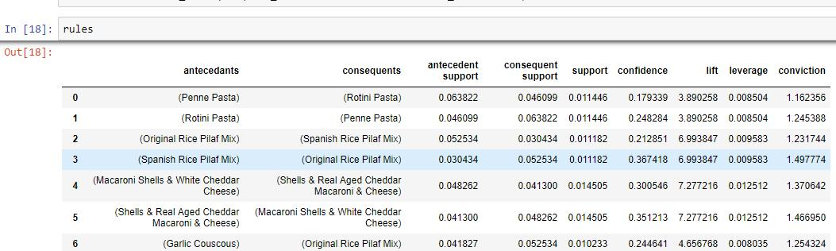

Result Analysis : Macroni Shell and Real Aged Cheddar have high associations with a lift value of 7.27

Department Meat Seafood
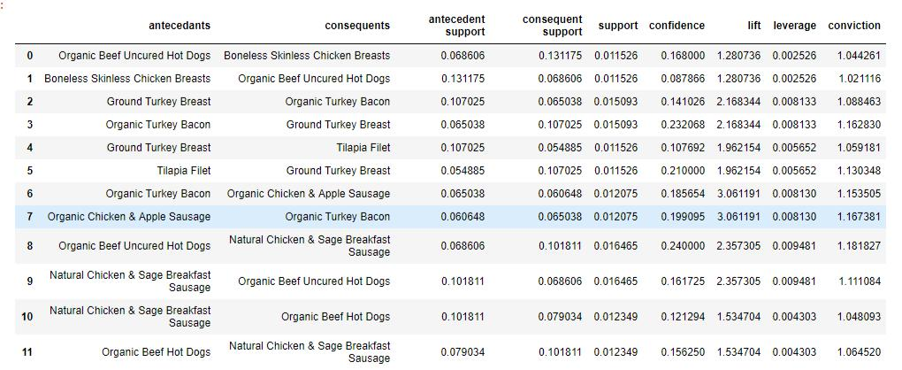

Result Analysis: Organic Turkey Bacon and Organic Turkey Breast have associations with Lift values of 2.

46 | P a g e
Instacart Recommendation Systems

Department Breakfast
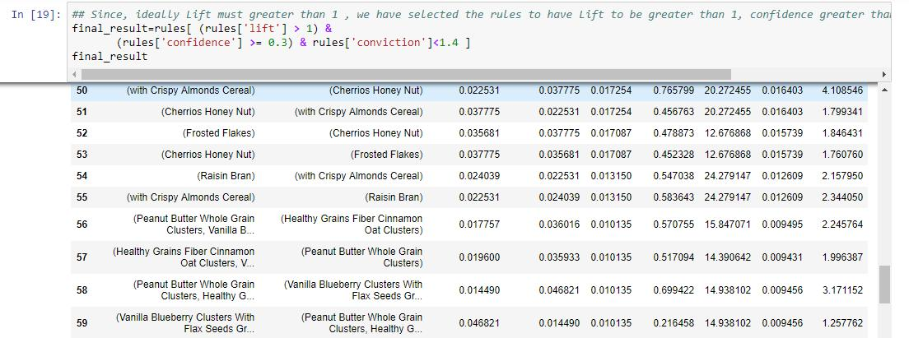

Result Analysis : Peanut Butter Whole Grain clusters and cinnamon clusters are bought together with a lift of 15

House Hold
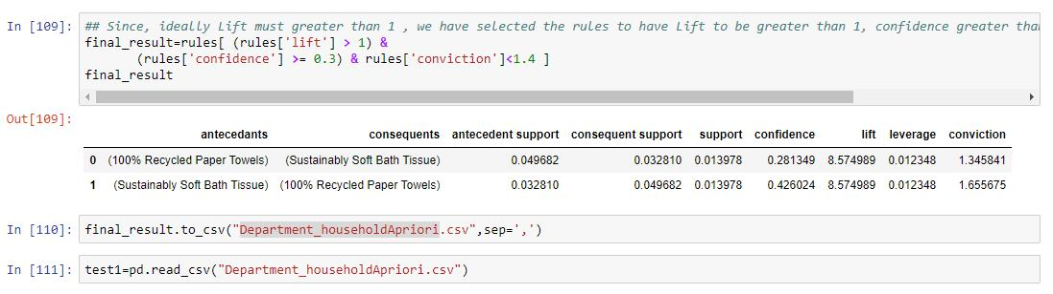

Result Analysis: Paper Towels and Soft Bath Tissue are bought together with a Lift of 8.57

Personal Care
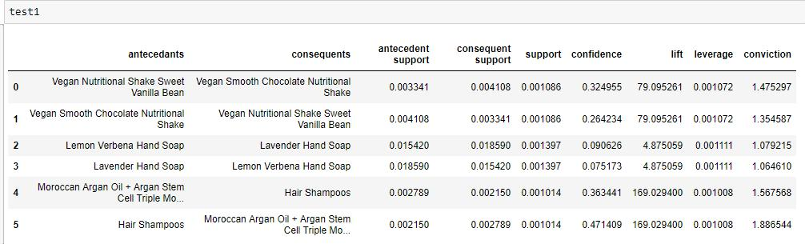

47 | P a g e
Instacart Recommendation Systems

Result Analysis : Morroccon Argan Oil and Shampoo is bought with a high Lift value

Department Babies
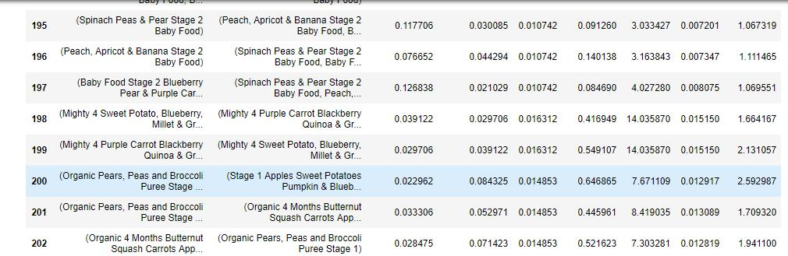

Result Analysis: Associations have a high lift of 14

Department International
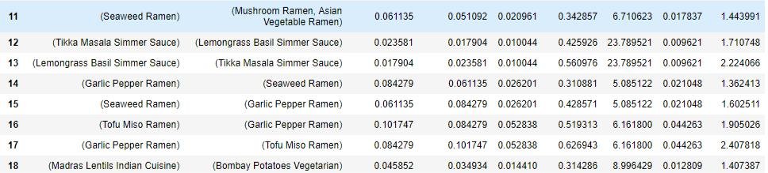

Result Analysis : Tikka Masala Simmer Sauce and Lemon Grass Simmer is bought together with a lift of 23

Alchohol
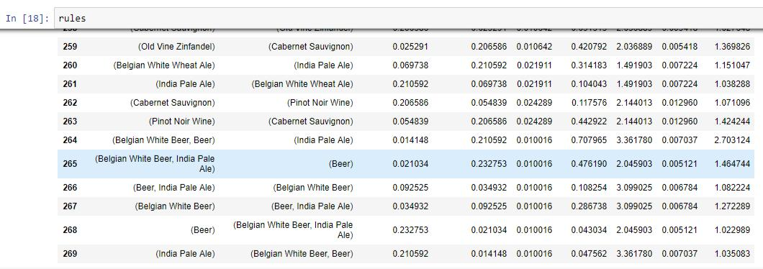

48 | P a g e
Instacart Recommendation Systems

Result Anaysis : Belgian Beer and India Pale Ale have a high a lift value 3.36.

Department Pets
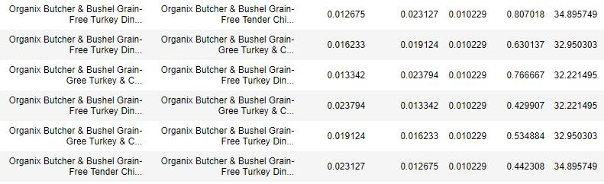

Result Analysis : Organix Butcher and Bushen Grain are bought together with a lift of 32 Department Missing
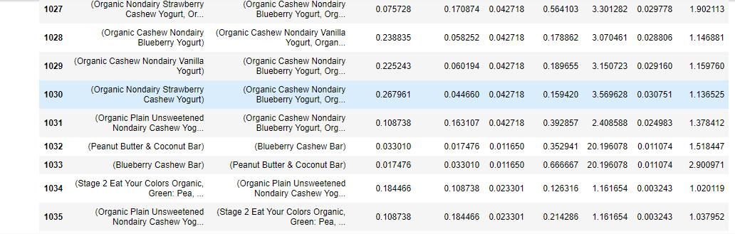

Result Analysis : Peanut Butter and Coconut Bar and Blueberry Cashew bar Grain are bought together with a lift of 20

49 | P a g e
Instacart Recommendation Systems

Other
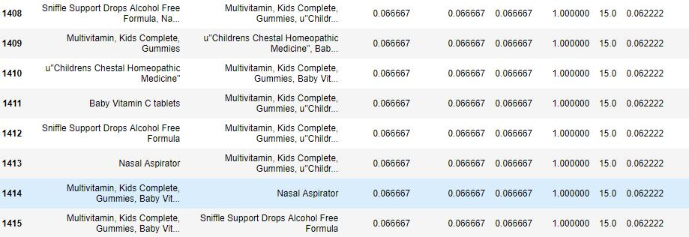

Result Analysis: All association have a Lift of 1

Department Bulk
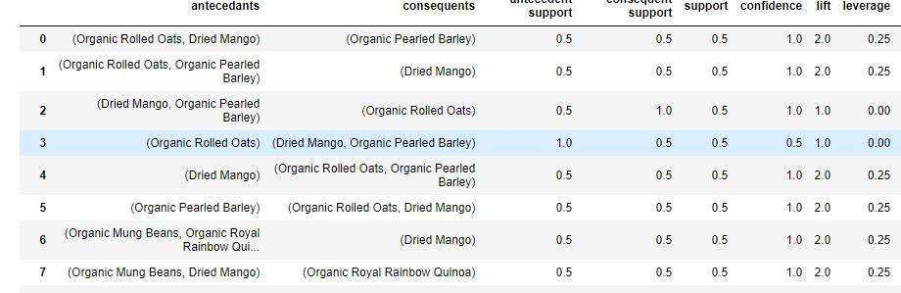

Result Analysis : All Associations have a result set of 2

50 | P a g e
Instacart Recommendation Systems

Implementation on the Web Application
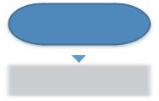

 |  |  |  |  |  |  |  |  |  |  | Start
 |  |  | Not Logged in
 |  |  |  |  |  |  |  |  |  | Logged in as User |  |  |  |  |  |  |  |  | Login as Admin
 |  |  | Home Page
 |  |  | (Popularity Based |  |  |  |  |  | Home Page with |  |  |  |  |  |  | Dashboard for
 |  |  | Recommendation |  |  |  |  |  | items to Restock by |  |  |  |  |  |  | Statistics |  |  |  |  |  |  |  | EDA
 |  |  | for new use + Most
 |  |  | Bought Products) |  |  |  |  |  | that user +
 |  |  |  |  |  |  |  |  | Recommendations
 |  |  |  |  |  |  |  |  | using Macthbox
 |  |  |  |  |  |  |  |  | Recommendation +
Select Item |  |  |  |  |  |  |  |  | Most Bought
 |  |  |  | Department Page |  |  |  |  | Products
 |  |  |  | (Popularity Based
 |  |  |  | Recommendation
 |  |  |  | for new user in that |  |  |  |  | Department Page
 |  |  |  | department + Most |  |  |  |  |  |  |  |  |  |  |  | Select Item
 |  |  |  |  |  |  |  |  | (Model Based
 |  |  |  | Bought Products in
 |  |  |  |  |  |  |  |  | Recommendation
 |  |  |  | that department)
 |  |  |  |  |  |  |  |  | for user in that
 |  |  |  |  |  |  |  |  | department + Most
 |  |  |  |  |  |  |  |  | Bought Products in
 |  |  |  |  |  |  |  |  | that department)
 |  |  |  | Select Item
 |  |  |  |  |  |  |  |  | Select Item
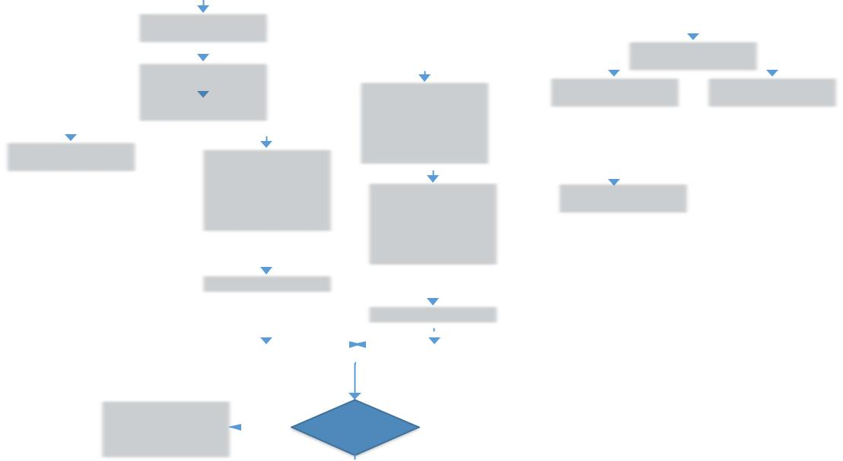

Provide Top |  |  |  |  | Associations
products from that |  |  | No |  | Found?
department
 |  |  |  |  |  | YES
 |  |  |  |  | Provide the
 |  |  |  |  | Frequently Bought
 |  |  |  |  | together products
 |  |  |  |  | found by the Apriori
 |  |  |  |  | Algorithm


URL: http://35.190.167.191/

The web application handles 3 kinds of users

- New User

- Existing User

- Administrator

On selecting a product from a department or from the homepage, the user is provided recommendations using the recommendation models. Once, the product is selected the user is provided options based on the association rules. If no association is found the user is prompted with the most popular product.

Conclusion

Recommendation Systems are a large scope in the industry , considering the information overload due to the internet. Recommendation Systems for Instacart improves the user experience and hence, ensures that the user to be a returning user. This also helps reduce customer churn.

Model Based recommendation provided the best precision of 0.28. Apriori provided the best lift 128

51 | P a g e
Instacart Recommendation Systems

52 | P a g e
Instacart Recommendation Systems

53 | P a g e

